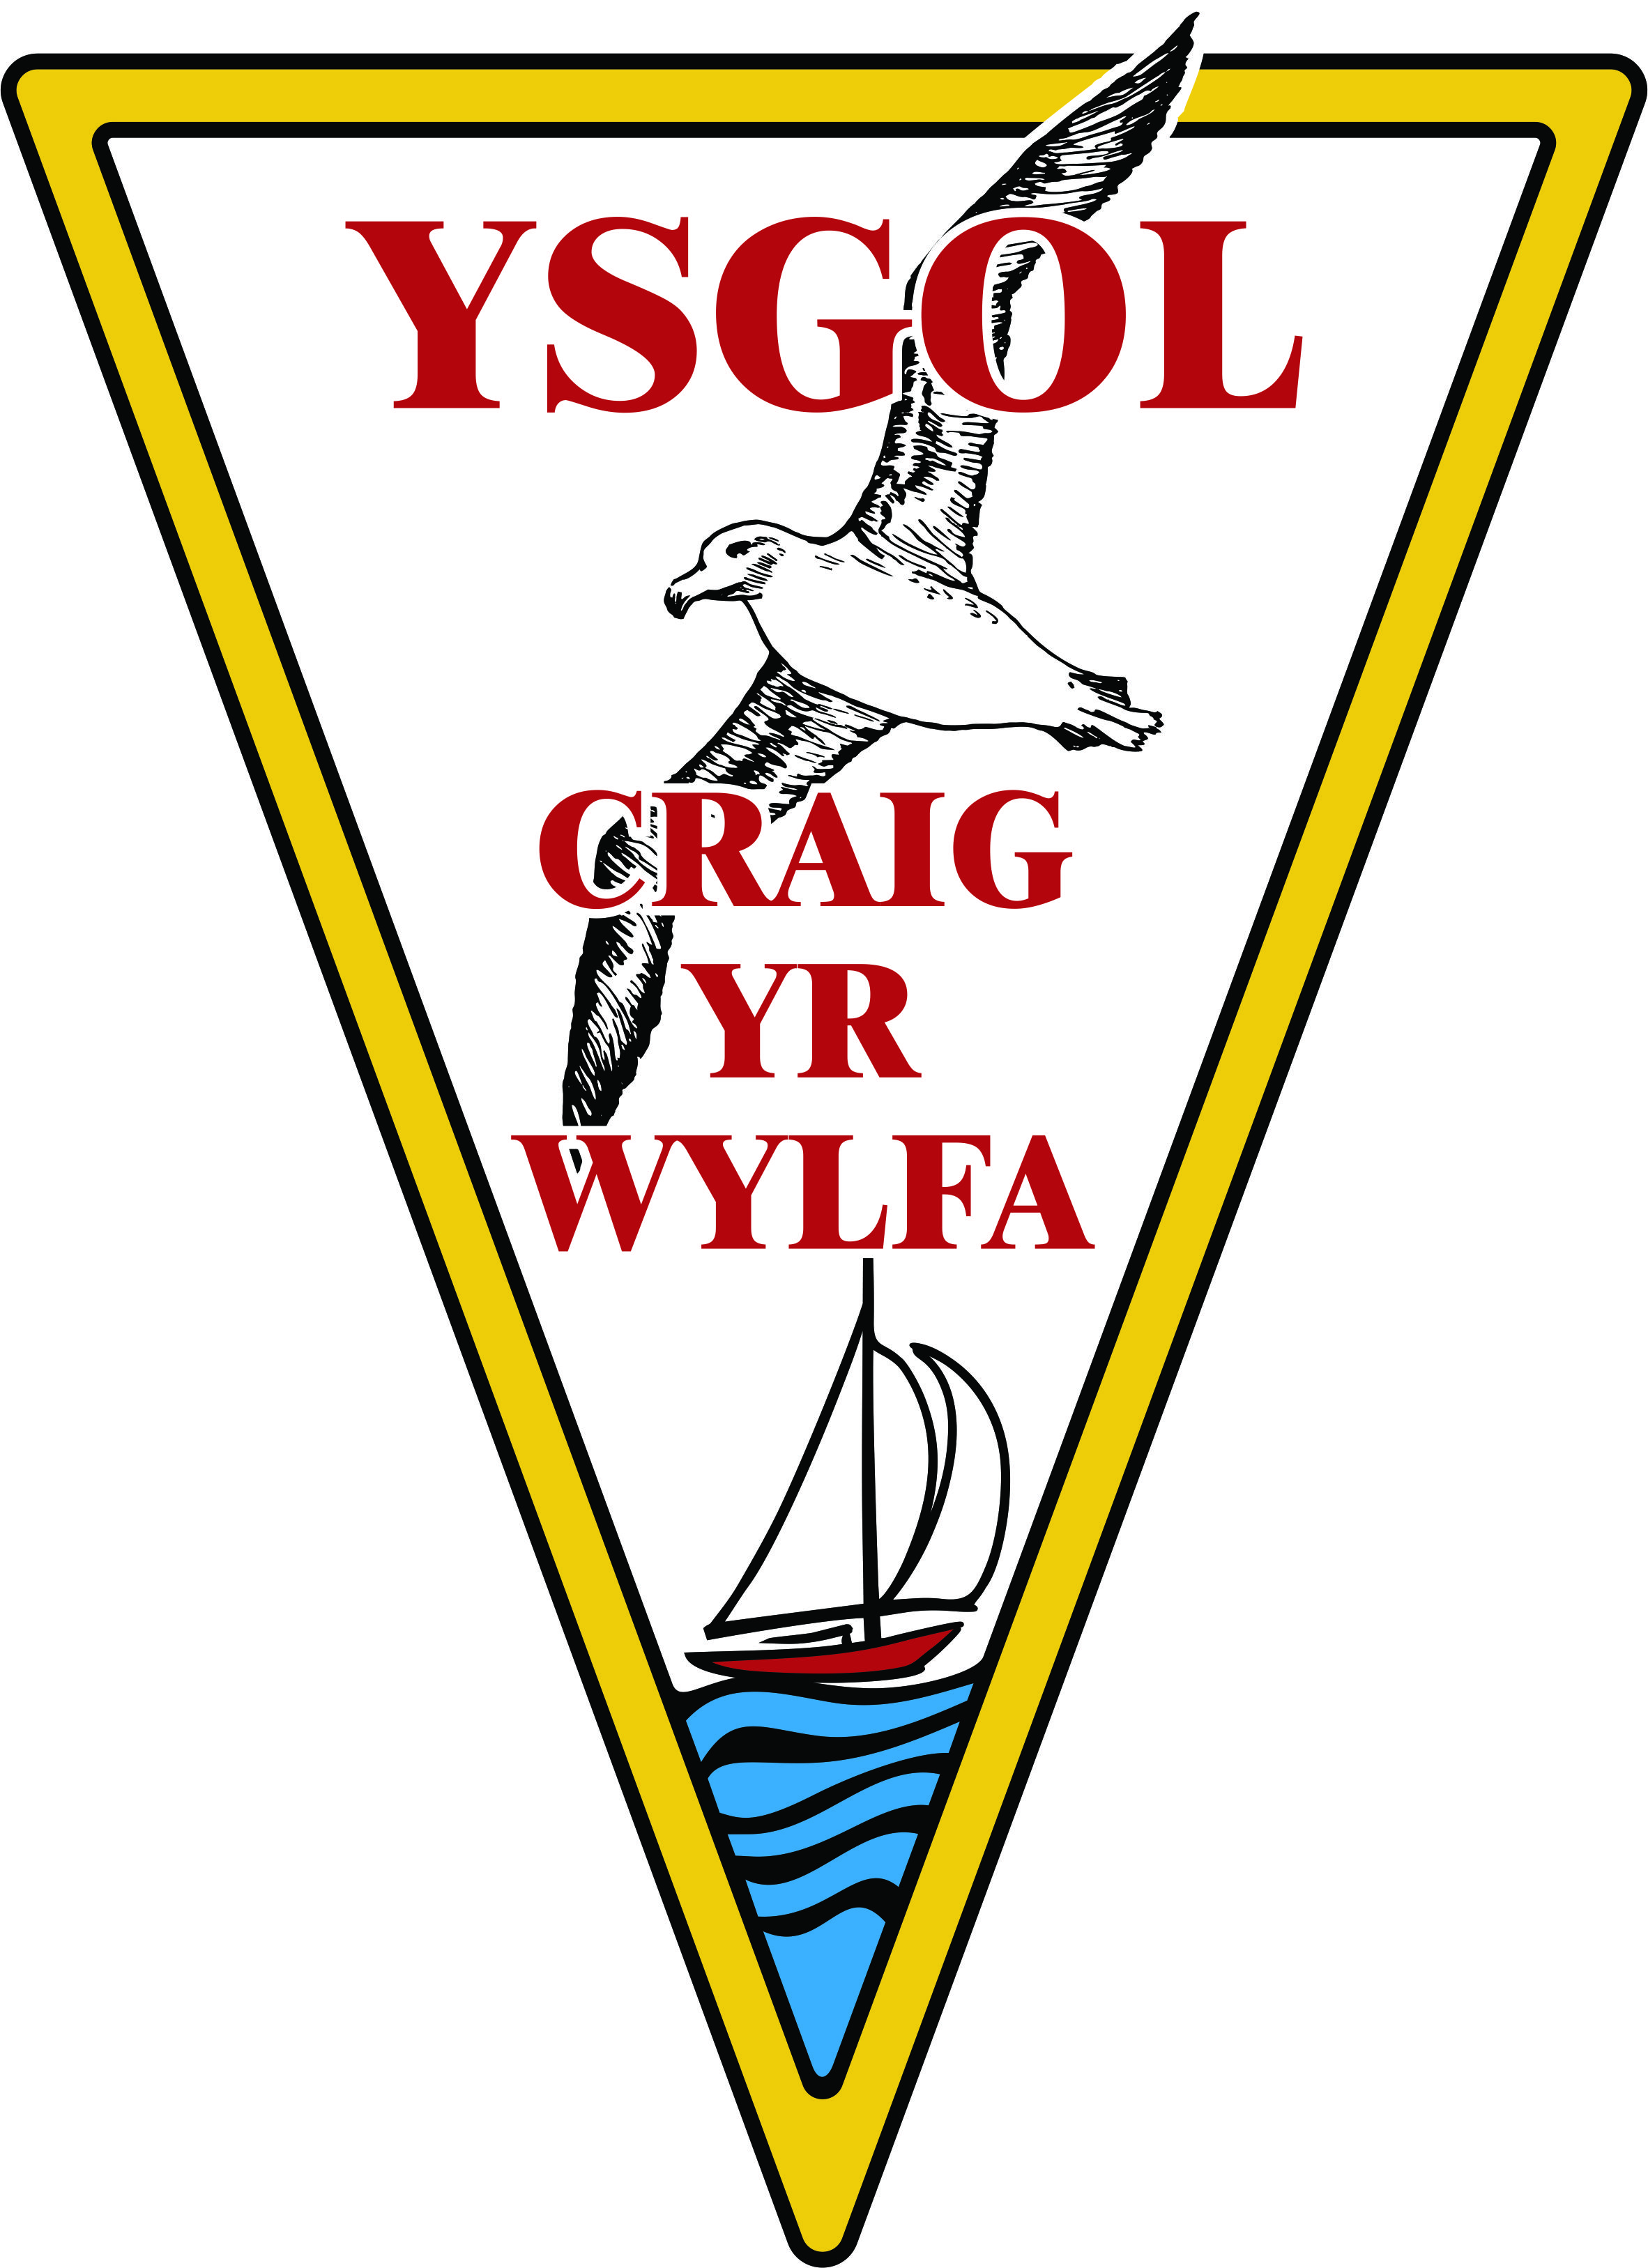
Ysgol Craig yr Wylfa
Play Policy

Play is an essential part of a child’s life. The school takes children’s play seriously. It is the role of the staff to offer a wide range of play opportunities that enable children to play freely and be the masters of their own play.

All children and young people need to play: the impulse to play is innate. Play is a biological, psychological and social necessity, and is fundamental to the healthy development and wellbeing of individuals and communities.
Play is a process that is freely chosen, personally directed and intrinsically motivated. That is, children and young people determine and control the content and intent of their play, by following their own instincts, ideas and interests, in their own way for their own reasons.
The prime focus and essence of staff is to support and facilitate play.
To play is to allow one to freely explore and make sense of the world, experiment, and express things without fear of judgement.

To best facilitate children’s play
The role of the staff is to support all children and young people in the creation of a space in which they can play. This will include appropriate assessment of activities to balance risk with the benefits to the child/young persons development.
The environment will be set up prior to children arriving and will include a range of play opportunities.
Children will be confident in making requests for other equipment. Equipment set up/provided may be used in conjunction with other additional equipment.
Children are not required to be occupied at all times.
The staff's response to children and young people playing is based on a sound up to date knowledge of the play process, and reflective practice.
Staff recognise their own impact on the play space and also the impact of children and young people’s play on the staff.
Staff choose an intervention style that enables children and young people to extend their play. All staff intervention must balance risk with the developmental benefit and wellbeing of children.
Staff recognise that children need to put their own creative style and ideas into their creations such as cooking, arts, crafts, sports and gardening.
Children will be given the opportunity to be involved in planning activities so that the programme reflects their opinions. Activities will be carefully planned to allow children to build on their natural curiosity, advance their thinking and use their imagination.
Children will be given notice when their play must come to an end. If a play request is refused an explanation will be given.

Outdoor Play
Children will be offered access to outdoor play every day, with the exception of severe weather conditions.
Any outdoor play will take place in safe, appropriately supervised spaces. Before any outdoor activities commence, safety checks are carried out.
The equipment and resources reflect positive images with regard to culture, ethnicity, gender, and disability.
Activities will be evaluated by staff and children regularly so play experiences and activities can be improved.

Equipment
The school will provide a wide range of resources and equipment in order to provide a range of play opportunities and activities and enhance children’s play experiences.
Resources will, whenever possible, show men and women in a variety of roles and jobs, and people with different abilities being both active and creative. Examples of every day life will portray people from a variety of family groupings and cultural backgrounds in a range of non-stereotypical roles.

This policy was compiled by Michelle James (Healthy Schools Co-ordinator)

This policy was implemented February 2014

Review date September 2015

