 | Ysgol Craig Yr Wylfa  Heol Ffransis,Borth,Ceredigion.SY24 5NJ  Ffôn: 01970 871280 prif@craigyrwylfa.ceredigion.sch.uk | 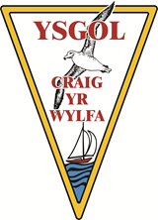
10/10/19
Dear Johnny,
Thank you very much for the £100 that you gave to the school. We are delighted to know that you think so highly of our school and we would like to let you know how we intend to spend the money.
We, as the school council, have had many fabulous ideas on how we can improve Ysgol Craig yr Wylfa but we have decided that the best way to spend the money that you gave us on some equipment for playtimes, i.e. skipping ropes, cones, chalk and also to buy some new board games so that we have things to play with during wet play.
I really hope that you are happy with our decision and we would like to say a very big thank you to you once again.
Yours sincerely,
School Council,
Ysgol Craig yr Wylfa

